

Standards and Quality Report 2024 - 2025

Castlehill Primary School


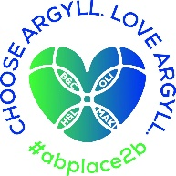


Context of the school
Including some or all of the following:
- basic school details (roll, class composition etc.)
- school vision, value and aims;
- local contextual issues;
- factors affecting progress (e.g. staffing changes/issues).

Castlehill Primary School is located in Campbeltown towards the southern end of the peninsula of Kintyre. It is one of two primary schools within the town. Local employment opportunities in South Kintyre include farming, the distillery industry, local government and the health service.

The roll for 2024/25 has risen to 178 and the anticipated school roll for 2024/25 is 187. We have had seven classes, which will rise to 8 in 25/26. The arrangement for 2025/26 will be: two P1 classes, P2, P3, P4, P5, P6 and P7/6. There are currently 28 members of school staff including three part-time Pupil Support Teachers and 10 Additional Support Needs Assistants.

The school is part of a three schools leadership structure arrangement, involving Carradale Primary and ELC and Drumlemble Primary and ELC, in which the Head Teacher has responsibility for all three schools. There is also a Depute Head Teacher across the three schools and a Depute Head Teacher and two Principal Teachers in Castlehill.

The school has strong links with Campbeltown Nursery, with which it coordinates an active transition calendar, and with Campbeltown Grammar School with which it liaises, alongside all other South Kintyre schools, throughout the year to ensure a smooth transition for P7 pupils into S1.

During the 24/25 session a Learning Centre was established within Castlehill, consisting of a main Learning Centre room, a Life Skills room, two sensory rooms and an outdoor area. Pupils with additional support needs have benefited from being able to access the Centre and classes have also been able to make use of the Life Skills room particularly for food preparation and cooking. We are awaiting our first registrations and looking forward to offering the full use of the Centre and its resources to benefit those pupils in the future.

The school’s Vision, Values and Aims are as follows:

Vision

We strive to provide a nurturing, safe and engaging environment for our learners by encouraging emotional resilience and curiosity, and providing appropriate challenge to allow everyone to feel a sense of pride in their achievements.

We value:
- Creativity
- Kindness
- Friendship
- Respect
- Responsibility

Our aims are to:
- Equip our learners with skills and knowledge that will allow them to thrive in an unknown future and make their own choices in regards to their career path.
- Provide a wide range of opportunities that encourage exploration of individual strengths, as well as allowing our learners to feel a sense of connectedness to their community and the wider world.
- Build strong children by respecting their rights and encouraging self-regulation and resilience in the face of challenges.
We reviewed our vision, values and aims with all stakeholders during 2022/23 and 2023/24 and have embedded them in our curriculum and daily practice during 2024/25.

Review of SIP | Priority 1
Literacy - Writing
Progress and Impact:
Our P6 teacher engaged fully in Argyll and Bute’s QI Approach to improving writing, and our P3 and P5/4 teachers continued to follow the principles of the approach. Key principles of the approach were also applied across all classes with a view to raising attainment in writing in each class: pre-assessment analysis, the setting of stretch aims, the setting of teaching aims, the identification of a target group and the planning of the intervention.
The QI approach was also applied specifically by the P6 teacher in a Maths project focused on mathematical reasoning and more broadly across the school in Numeracy in the setting of stretch aims and planning interventions for targeted groups.
Additional teacher input into our P7 class was provided by our Depute Head Teacher. An arrangement was put in place to split the class between class teacher and Depute Head Teacher once a week for the focused teaching of writing, linked to the class’s teaching aim. The arrangement enabled the targeted support of groups and individuals.
A new Writing Genre Progression was created in consultation with teachers and integrated into teachers’ planning. The progression provides a more systematic sequence of genres for pupils to experience from P1 to P7, providing a more coherent structure for building on previous learning.
As a staff we engaged in the Guided Approach to Pedagogical Enquiry model of professional learning. We focused on modules relating to Learning Intentions and Success Criteria, Questioning and Meta-cognition. The principles were applied to learning and teaching across the curriculum with a particular focus on Literacy and Numeracy. Observations and feedback from teachers showed the model was having a positive impact on learning.
Most pupils across the school are on track to achieve, or have achieved, the expected level in writing. The percentage of pupils on track in June 2025 (76%) in writing increased by 8% from June 2024 (68%). The percentage for June 2025 was 1% above the target set in August 2024 (75%).
Where the QI approach was implemented in full in P6, through the class teacher’s participation in the authority’s training/initiative, the percentage of pupils in the class on track rose from 60% in June 2024 to 85% in June 2025.
Where additional input was provided by our Depute Head Teacher in P7, the percentage of pupils in the class on track rose from 50% to 74%. The P7 class teacher reported that the additional targeted support twice a week gave pupils additional confidence to apply newly acquired skills across the rest of the week.
The cumulative percentage of pupils on track across P1, P4 and P7 in June 2025 (77%) decreased slightly by 2% from June 2024 (79%) but within those cohorts good progress was made in that the number of pupils on track in P1 was 83%, in P4 79% (up from 47% in June 2024) and in P7, as stated above, 74%, (up from 50%) in June 2024.

Next Steps:
- Continue focus on raising attainment in Writing:
- Continue development of the QI approach to writing, targeting key year groups – Primary 4 and Primary 6 in August term.
- Increase opportunities for writing across the curriculum/for a real purpose. Link in with playful experiences.
- Continue to use additional targeted Depute Head Teacher teaching input as intervention to enable boosting support for pupils in identified classes (initially in P2 and P4 for Numeracy).

Review of SIP | Priority 2
Numeracy
Progress and Impact:
We reviewed our main teaching resources, schemes and programmes in use across the school and purchased substantial elements of two schemes to provide updated and consistent teaching and learning resources for use from P1 to P7. The resources have been integrated into planning and teaching alongside other learning and teaching resources and strategies. The resources provided support for teachers by providing clear progressions and supporting teaching ideas for the application of skills. Feedback from teachers has been positive about the resources and how they can link to our planning progressions. Further work is planned to look more systematically at identifying the links for future planning.
The principles of the QI approach to raising attainment were applied in all classes, as set out above for writing.
As for writing, additional teacher input into our P7 class was provided by our Depute Head Teacher. An arrangement was put in place to split the class between class teacher and Depute Head Teacher once a week for the focused teaching of numeracy. The arrangement enabled targeted support of groups and individuals.
The focus of the authority’s moderation for this year was numeracy and maths. We took part in this moderation process which enabled class teachers from the South Kintyre Cluster to work together on the planning and delivery of an agreed task. Our P7 teacher worked with other P7 teachers and teachers from Campbeltown Grammar School. Through this model, expectations and standards were shared with local schools. The collaborative planning that took place around the creation of high quality maths assessments was beneficial. In-school moderation around termly assessments continues to embed shared understanding of standards within the school. Further moderation is planned for 2025/26 from January to June 2026 around strands of numeracy and maths identified through analysis of end of year standardised assessments.
The professional learning from the Guided Approach to Pedagogical Enquiry was applied to learning and teaching in numeracy.
Most pupils across the school are on track to achieve, or achieved, the expected level in numeracy. The percentage of pupils on track in June 2025 (81%) in writing increased by 5% from June 2024 (76%). The percentage for June 2025 was 6% above the target set in August 2024 (75%).
Where additional input was provided by our Depute Head Teacher in P7, the percentage of pupils in the class on track rose from 63% to 77%.
The cumulative percentage of pupils on track across P1, P4 and P7 in June 2025 (81%) increased by 5% from June 2024 (76%).
The percentage of pupils on track in each of the cohorts from P2 to P7, except one, increased from June 2024 to June 2025. In the one exception where there was a decrease, the percentage remained very high at 95%.
Next Steps:
- Continue focus on raising attainment in Numeracy and maths:
- Plan for staff to attend online Counting on Excellence training from September to December
- Plan whole school moderation of identified strands of numeracy and maths.
- Update planners to link effectively to new resources – Leckie and Counting on Excellence.
- Continue to use additional targeted Depute Head Teacher teaching input as intervention to enable boosting support for pupils in identified classes (initially in P2 and P4 for Numeracy).
Review of SIP | Priority 3
Learning across the curriculum
Progress and Impact:
RSHP
The teaching of RSHP through the national RSHP ( https://rshp.scot ) resource was fully implemented across the school from the Autumn Term, having been partially implemented in the Summer Term of 2024. An information event had been held for parents in Spring 2024 setting out the phased implementation. Follow up information about the full implementation was available for parents in 24/25 and information was shared with parents of new P1 pupils about the school’s adoption of the RSHP programme.

The implementation of the RSHP resource has linked well with the writing of our new Relationships Policy in the Autumn Term and the sharing of it with parents. The resource and policy have provided a coherent approach to teaching and support around pupils’ understanding of relationships and supported our approach to the management of behaviour. Pupil Focus Group feedback indicates that pupils recognise staff commitment to ensuring that their health and wellbeing and respectful relationships are priorities: 'Teachers explain what we should and shouldn't do', 'We are listened to', 'Adults treat us with respect', 'You can see respect in our school and people who go to our school'.

Physical Activity
A whole school progression linked to programmes of work has been created. Our Principal Teacher has led this development. The progression means that the planning teams across the school, P1-3, P4-5 and P6-7, can work collaboratively on planning and resourcing for sequences of lessons, thereby ensuring greater consistency and progression in the learning of skills.

Physical activity across the school is a strength in terms of the wider curriculum opportunities it provides. All year groups have the opportunity to take part in South Kintyre’s Active Schools Virtual Games Clubs. In addition our Principal Teacher organised a school Virtual Games competition for classes to compete in. A number of sports clubs, set out in the wider achievement section below, were run this year. A Sports Day and a mixed class whole school Sports Event are held each year, providing opportunities for individual and team achievements. P7 buddies supported younger pupils through lunchtime clubs. We have an established Sports Council. We were awarded Sport Scotland Gold Award status previously and are on track to maintain that status.

IT
One of our support staff has played in leading role in organising and maintaining devices so that they are utilised more effectively as a learning resource by classes. Class sets of chromebooks and iPads are effectively used by classes on a weekly timetable. Assistive technology support has been provided by our Pupil Support Teachers for individuals and groups in P6 and P7. A new IT progression planner was created by our three schools Depute Head Teacher with teachers at the early stage of implementing it.

Outdoor Learning / Sustainability
A teacher has been designated to lead the teaching of outdoor learning and sustainability across the school. This has meant that all classes have been engaging in outdoor learning consistently throughout the year. Our school garden has been used constructively for growing and investigative work. An application for the Keep Scotland Beautiful LEAF award was submitted successfully in the Summer Term on behalf of the work done with P1-3 classes. An Eco Schools committee has been established and an application for Eco-Schools accreditation has been prepared for submission in the Autumn Term. Whole school and P7 GRAB Trust Beach Litter Project awards have been awarded in the Summer Term. The use of off-site local areas has been increased this year. Pupils in off-site outdoor learning activities have been observed showing good levels of engagement.

Planning for outdoor learning and sustainability has strengthened opportunities for the practical application of learning in a number of curriculum areas: Listening and Talking, Health and Wellbeing, Science, Maths and Social Studies.

Learning Centre
Our new Learning Centre building works have been completed. The centre room, life skills room and sensory rooms have been set up for use by pupils in the school. As yet we do not have any registered pupils but the centre has been used very successfully to support pupils with additional support needs who benefit from the opportunities the centre can provide: personalised and small group learning support, indoor and outdoor play, sensory and nurture support. An Open Event was held successfully for members of the community and external agencies in the Summer Term and we are looking forward to welcoming registrations in the future and utilising the centre as a resource to enhance the support we provide for pupils with additional support needs.
Next Steps:
- Embed the implementation of:
  - The national RSHP programme.
  - Our new PE progression overview.
  - Our new IT planning progression
- Continue the development of our outdoor learning / sustainability initiative.
- Continue the development of the use of the Learning Centre to enhance our provision for additional support needs.

1.1 Attainment Data
Attainment of Literacy Curriculum for Excellence levels 2020/21, 2021/22, 2022/23, 2023/24 and 2024-2025 (teacher judgement – confirmed levels – 5 year trend).
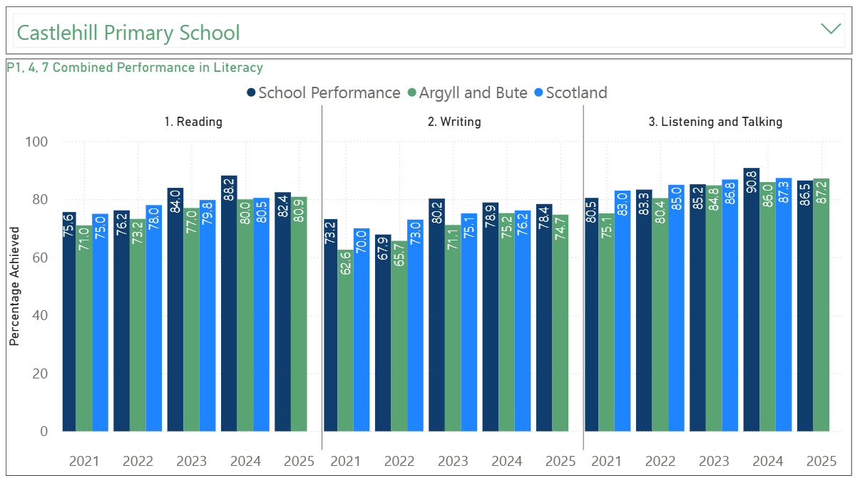

1.2 Attainment Data
Attainment of Numeracy Curriculum for Excellence levels 2020/21, 2021/22, 2022/23, 2023/24 and 2024-2025 (teacher judgement – confirmed levels – 5 year trend).
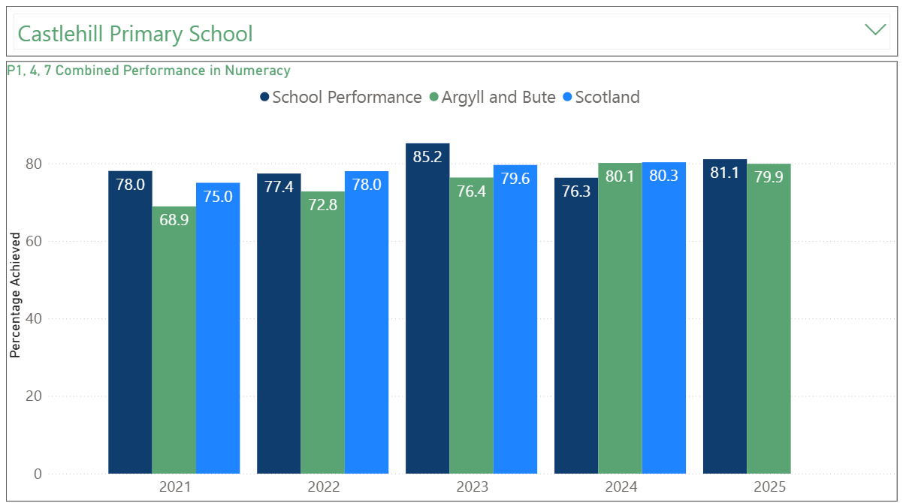
Please Note: The above data (1.1 and 1.2) reports achievement of a level – P1/P4/P7 combined.

Wider achievements
- What opportunities for wider achievement were offered?
- What systems are in place to track and monitor participation?
- How have you addressed any gaps in participation?
A strength across the school is the wide range of extra-curricular clubs that are offered. These are largely offered at lunchtime to ensure that they are as inclusive as possible but some are offered as after school clubs to allow longer time to be spent learning together. Clubs that were offered this year were:
- STEM P1-3, P4-5, P6-7
- P1 Yoga
- P2 Boccia
- Virtual Games P1-3, P4-5, P6-7
- P3 Athletics
- P5 Basketball
- P5 CGS
- P5-7 Ceilidh
- P5-7 Football
- P6-7 Drama
- P6 Euroquiz
- P7 Badminton
- P7 Pickleball
Primary 7 have had opportunities to develop strong leadership skills, running clubs all year round for Primary 1-3 in the front playground. They have also been able to act as buddies for the Primary 1s through weekly play and reading sessions. A group of Primary 7s were also given the opportunity to run two Euro Tournament football sessions for Primary 1 and 2.
Two primary 5 girls then wrote a letter asking if they could run a club for Primary 3 and 4. They independently planned for this and completed a block of Ball Games.
We run our weekly Wonder Wall Wednesday sessions. Every fortnight, pupils are encouraged to bring in achievements from home. These may be from clubs or from activities completed at home such as creating, baking or helping. Every other week, we celebrate our school values. 2 pupils from each class are nominated by their class teachers and they join the DHT for a hot chocolate and chat about their successes.
All of the above is tracked on our Wider Achievements spreadsheet. We analysed this in April of this year to identify any pupils who had not been recognised in some way for their participation in a wider achievement. We initially identified 7 pupils. From this, we looked back at our parent surveys from the start of the year, where we asked about wider achievements at home. This allowed for a conversation with 3 pupils who then brought achievements in from home for Wonder Wall Wednesday. We recognised 2 pupils for wider achievements in the life and ethos of the school. For the final 2 pupils, we discussed with them what clubs they would like to attend. One wanted to join STEM so we approached the family and this happened. The second joined his class for a fitness club.
In addition to this, we promoted wider achievement through; participation in the Rotary Quiz, the Millennium and Baldy Cup competitions (having 46 pupils from P5-7 complete, some who had not played football until this year), the local Drama Festival, the Girls’ Rugby Day, a visit from Scottish Parliament, visits from Jo Oliver UHI STEM Leader with workshops for Primary 1 and Primary 7, SCAA fundraising, beach cleans and litter picks for Primary 3-7 with GRAB trust (following which 2 pupils were recognised in the local community for carrying out their own litter pick), use of the tennis club, film-making workshop and follow up production of films that were shown at the cinema, outdoor learning for all classes resulting in lots of fresh produce from the garden which was cooked in school, class trips including the Primary 7 visit to the Scout Centre in Lochgoilhead, cooking opportunities in our life skills room, Bikeability training for Primary 6 and 7, a rocket launch as part of P1-2 Space topic, Enterprise topics leading to Winterfest, Careers Week Scotland with a number of visits from local Entrepreneurs, McMillan Coffee Morning led by Primary 5/4, visits to the Gateway Garden and our Buddies Programme. This is all evidenced on our school Facebook Page.
Furthermore, we expanded our school prize-giving this year with the introduction of new class awards. These were discussed and agreed upon with our parent council. It was decided that each class would award an Innovation, Endeavour and Achievement award. We also introduced a trophy for Drama and the Arts. It is the plan that during the 25-26 session, we will look again at the format of our Prize-giving and any further changes that may ensure that it is balanced, and reflective of the wide range of talents and abilities we have in school.
Finally, we promoted engagement in non-school extra-curricular clubs and activities through our Facebook page and by handing out information leaflets and consent forms in school. We have a very significant number of children attending local badminton competitions, golf competitions, Live Argyll Clubs and Experiences, Swim Club, and CDJFA football training. These are all celebrated as part of Wonder Wall Wednesday.

Pupil Equity Funding
Summarise progress and next steps in relation to pupil equity funding

Progress and Impact:
Our broad PEF Identified Group represents 42% of our school roll.
Our PEF Target Group, consisting of pupils assessed as not on track in Curriculum for Excellence XBRA assessments at June 2024, represents:
- For Listening and Talking, 7% of our school roll.
- For Reading, 8% of our school roll.
- For Writing, 11% of our school roll
- For Numeracy, 6% of our school roll
Numeracy
Support for pupils has included the use of a new maths scheme, personalised and small group support, including SEAL reinforcement for older pupils, and the use of IT resources including Sumdog.
97% of our broad PEF Identified Group, for whom comparative data is available, made at least one sub-level of progress in XBRA assessments from June 2024 to June 2025.
82% of our PEF Target Group, for whom comparative data is available, made at least one sub-level of progress in XBRA assessments from June 2024 to June 2025.
85% of our Identified Group, for whom comparative data is available, are on track at June 2025, compared to 83% at June 2024.
Of our targeted group, all of whom were not on track at June 2024, 36% made accelerated progress to be assessed as on track at June 2025.
The barriers for the pupils not making the sub-level of progress or accelerated progress were their additional support needs for which long-term support planning is in place or significant difficulties relating to attendance.
Teachers assessed the progress of the pupils in our PEF Target Group in Sumdog as: 100% of pupils made steady progress with 50% making very good progress.
Reading and Writing
Support for pupils has included personalised and small group support and the use of IT resources including Nessy and Spelling Frame.
Reading
90% of our broad PEF identified group, for whom comparative data is available, made at least one sub-level of progress in XBRA assessments from June 2024 to June 2025.
86% of our PEF targeted group, for whom comparative data is available, made at least one sub-level of progress in XBRA assessments from June 2024 to June 2025.
85% of our identified group, for whom comparative data is available, are on track at June 2025, compared to 77% at June 2024.
Of our targeted group, all of whom were not on track at June 2024, 50% made accelerated progress to be assessed as on track at June 2025.
The barriers for almost all of the pupils not making the sub-level of progress or accelerated progress were their additional support needs for which long-term support planning is in place or significant difficulties relating to attendance. Where additional support needs have not been identified, further assessment of individual needs and targeting of support is planned.
Writing
92% of our broad PEF identified group, for whom comparative data is available, made at least one sub-level of progress in XBRA assessments from June 2024 to June 2025.
89% of our PEF targeted group, for whom comparative data is available, made at least one sub-level of progress in XBRA assessments from June 2024 to June 2025.
76% of our identified group, for whom comparative data is available, are on track at June 2025, compared to 70% at June 2024.
Of our targeted group, all of whom were not on track at June 2024, 37% made accelerated progress to be assessed as on track at June 2025.
The barriers for almost all the pupils not making not making the sub-level of progress or accelerated progress were their complex or specific additional support needs for which long-term support planning is in place or significant difficulties relating to attendance. Where additional support needs have not been identified, further assessment of individual needs and targeting of support is planned.
Teachers assessed the progress of the pupils in our PEF Target Group within the Spelling Frame programme as: 76% of pupils made steady progress with 35% making very good progress. Further assessment and personalising of support is required for those pupils the 24% who made limited progress using the programme.
Teachers assessed the progress of the pupils in our PEF Target Group within the Nessy Literacy programme as: 81% of pupils made steady progress with 36% making very good progress. Further assessment and personalising of support is required for those pupils the 18% who made limited progress using the programme.

Wellbeing
Initiatives, programmes and interventions to support pupils’ wellbeing, confidence, communication and motivation included the provision of weekly outdoor learning sessions, Lego Therapy/Club for P1 pupils, the Seasons for Growth programme, and personalised and small group support resources and programmes, including the FRIENDS programme.
Listening and Talking
Assessment of attainment and progress in Listening and Talking has been used one indicator of confidence in communication and wellbeing for our broad identified and targeted PEF groups.
93% of our broad PEF identified group, for whom comparative data is available, made at least one sub-level of progress in XBRA assessments from June 2024 to June 2025.
93% of our PEF targeted group, for whom comparative data is available, made at least one sub-level of progress in XBRA assessments from June 2024 to June 2025.
87% of our identified group, for whom comparative data is available, are on track at June 2025, compared to 81% at June 2024.
Of our targeted group, all of whom were not on track at June 2024, 58% made accelerated progress to be assessed as on track at June 2025.
The barriers for almost all of the pupils not making the sub-level of progress or accelerated progress were their additional support needs for which long-term support planning is in place. Where additional support needs have not been identified, further assessment of individual needs and targeting of support is planned.

Wellbeing Initiatives
Two Seasons for Growth series of sessions were run, one for P1-3 and one for P4-7 to support pupils in the understanding and management of change and its impact on their emotions in their lives. Drop-in sessions for pupils have been available for all those who have completed a completed series of sessions, in order to provide a nurturing place to go each week and to maintain their contact and relationship with the Seasons for Growth leaders.
Seasons for Growth pupil and parent evaluations show positive feedback for most pupils. 86% of completed parent surveys reported that the effectiveness of the Seasons for Growth programme in helping their child understand and cope with change or loss was good or better. 100% of parent surveys reported that the effectiveness was satisfactory or better.

89% of pupils who reported back on their experience indicated that they had a good understanding of change and 100% reported positively that about the choices they can make to manage their feelings.
Pupils are keen to return to Seasons for Growth drop-in sessions. Individuals have expressed to the group leaders how the Seasons for Growth programme has helped them to understand changes in their lives and to know how to manage their emotions when change happens.
Lego Therapy/Club was provided for pupils in P1 throughout the year, providing opportunities for children to learn and develop co-operation and self-regulation skills in a structured play environment. Leuven Scale assessments showed improvement for all pupils in our PEF Identified Group across sequences of sessions for pupils’ involvement in, and wellbeing during, activities.
Outdoor learning weekly lessons provided additional stimuli for pupils to engage in practical learning with more opportunities to collaborate and listen and talk to each other in groups and grow in confidence as learners. Leuven Scales assessments of the pupils in our PEF Target Group showed the wellbeing of 60% of the pupils was assessed as high or very high and the involvement of 48% of pupils was assessed as high or very high in outdoor learning situations. Further development of our outdoor provision and assessment at more points in the year and planning to meet the additional support needs of pupils is planned.
Personalised and small group support resources and programmes, including the ‘Friends’ programme have been made available to enable pupils with significant needs to engage successfully in learning and social situations. 75% of the pupils who were involved and who were in our PEF Identified Group made good progress in the use of strategies to help them to manage social situations they find challenging, to make good choices and to develop positive relationships. Additional support was provided where further support needs were identified.

